* High content of fluoride in groundwater paves the way to excess fluoride in local food crops, consequently adding more fluoride to the systems of the consumers.
* People who work outdoors for prolonged periods consume excess water and tea, and are subjected to additional doses of fluoride in their system.
* In the mid-1980s, the increase in water table levels of the affected areas due to new irrigation projects paved the way to adding more fluorides to their system through drinking water and locally grown foods.

## Drinking water

* Based on the literature review conducted, one thing almost all investigators of CKD in Sri Lanka appear to agree on is the possibility of drinking water having a close association with cases of CKD in Sri Lanka. Therefore, upon considering a literature survey on CKD in Sri Lanka and further analysis, the author has decided to focus primarily on drinking water of the affected area.

## Fluoride

It has been reported that fluoride levels in water consumed by CKD patients in affected areas vary from 0.05 to 4.8 mg/L, with the mean value of 0.78 mg/L [[1](https://www.ncbi.nlm.nih.gov/pmc/articles/PMC4491063/#CR1)–[4](https://www.ncbi.nlm.nih.gov/pmc/articles/PMC4491063/#CR4)], which is well above the 0.5 mg/L, the limit recommended for tropical countries by the WHO [[4](https://www.ncbi.nlm.nih.gov/pmc/articles/PMC4491063/#CR4)]. Some reports provide alarming values as high as 3.9−7.3 mg/L fluoride levels in groundwater in some affected areas [[3](https://www.ncbi.nlm.nih.gov/pmc/articles/PMC4491063/#CR3), [9](https://www.ncbi.nlm.nih.gov/pmc/articles/PMC4491063/#CR9), [11](https://www.ncbi.nlm.nih.gov/pmc/articles/PMC4491063/#CR11)]. Incidentally, it is reported that dental and skeletal fluorosis is also widespread in these areas [[4](https://www.ncbi.nlm.nih.gov/pmc/articles/PMC4491063/#CR4)] and, therefore, it is apparent that people in CKD-affected areas in Sri Lanka are already being poisoned by high amounts of fluoride. This is why the author has opted to focus mainly on fluoride in drinking water in CKD-affected areas.

Fluoride from diet

Some researchers have been focusing on the heavy metals and the diet of the CKD-affected region [[5](https://www.ncbi.nlm.nih.gov/pmc/articles/PMC4491063/#CR5), [26](https://www.ncbi.nlm.nih.gov/pmc/articles/PMC4491063/#CR26)], when more attention should have been paid to the fluoride content of the locally grown foods and freshwater fish. Green leafy and other vegetables, pulses and products, and fruits are a staple part of the diet of people living in CKD-affected areas [[25](https://www.ncbi.nlm.nih.gov/pmc/articles/PMC4491063/#CR25)]. Vegetables, pulses, and other crops grown in this area should contain high contents of fluoride due to high levels of fluoride in both the soil and groundwater. For example, it is reported that amaranth, a cheap and popular vegetable green locally known as “Thampala”, excessively absorbs fluoride from the soil [[27](https://www.ncbi.nlm.nih.gov/pmc/articles/PMC4491063/#CR27)]. It is obvious that the crops grown in these areas of high fluoride concentrated soil will add more fluoride into the consumers’ systems through their diet. Researchers have measured the translocation of fluoride from soil to plant body and found that high fluoride concentrations in soil are indicated by high mean concentrations of fluoride in vegetables that are grown on that soil [[27](https://www.ncbi.nlm.nih.gov/pmc/articles/PMC4491063/#CR27)–[29](https://www.ncbi.nlm.nih.gov/pmc/articles/PMC4491063/#CR29)]. Therefore, a high concentration of fluoride in the soil is directly linked to the high fluoride in groundwater and surrounding vegetation.

1. There is enough medical evidence worldwide to prove that there is a direct connection between high fluoride levels in drinking water and kidney disease.
2. Fluoride excretion rate is considerably lower in children than adults, leading to renal damage of children living in areas with high fluoride.
3. Due to water–rock interactions in aquifers, ground water is predominantly fortified with this highly electronegative element, sometimes as high as 15%, depending on the geochemistry of the surrounding area.[1](https://journals.sagepub.com/doi/full/10.1177/0960327118814161)–[3](https://journals.sagepub.com/doi/full/10.1177/0960327118814161) Fluoride in water can easily make its way to human and animal bodies through the consumption of fluoride-tainted water and through diet.
4. The current World Health Organization Guideline recommendation on fluoride in drinking water is 1 ppm.
5. According to World Health Organization, standard rate of fluoride of drinking water is 0.5–1 ppm

.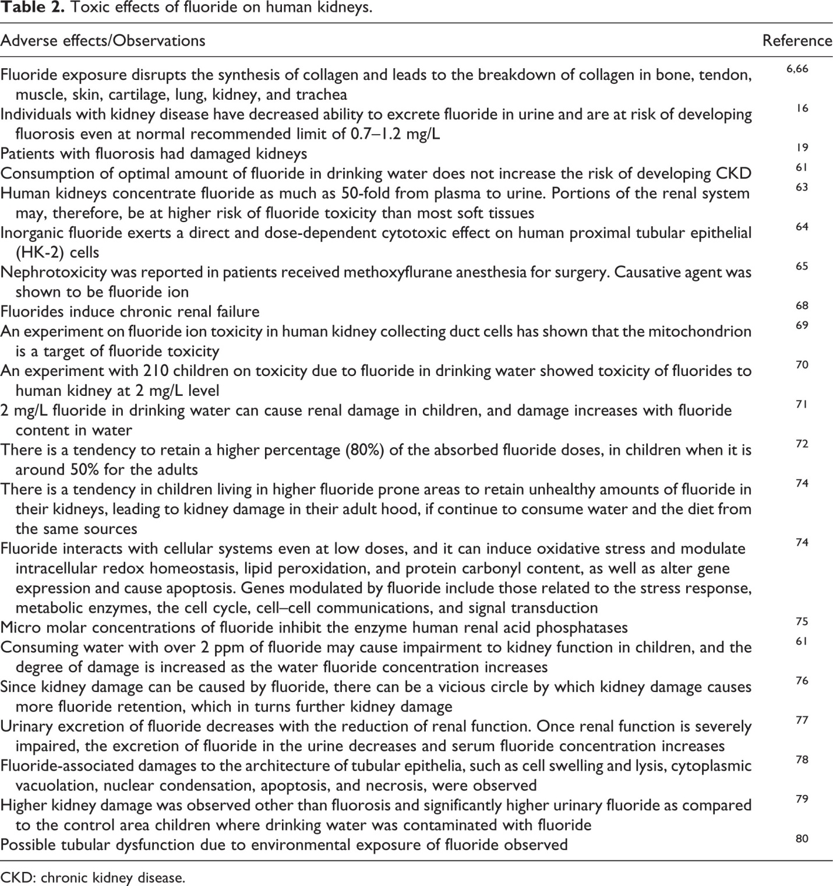

## Environmental factors

It is reported that the majority of CKD patients from the North Central Province of Sri Lanka do not show any identifiable causes, such as long-standing diabetes and hypertension, compared to their counterparts elsewhere.

A number of theories suggest that CKD occur due to fluoride, cadmium, arsenic, aluminum, mercury, uranium, vanadium, algal toxins or phosphates [[1](https://www.ncbi.nlm.nih.gov/pmc/articles/PMC4491063/#CR1)–[11](https://www.ncbi.nlm.nih.gov/pmc/articles/PMC4491063/#CR11), [13](https://www.ncbi.nlm.nih.gov/pmc/articles/PMC4491063/#CR13)], but none of these theories have been confirmed due to lack of sufficient scientific evidence

Another theory proposed talks about the increased ionicity of drinking water resulting from fertilizer runoff into the river system, redox processes in the soil, and features of ‘tank’-cascades and aquifers [[9](https://www.ncbi.nlm.nih.gov/pmc/articles/PMC4491063/#CR9)].

1. References

https://www.ncbi.nlm.nih.gov/pmc/articles/PMC4491063/#:~:text=There%20is%20enough%20medical%20evidence,in%20areas%20with%20high%20fluoride.